**eCVT-Mechanical**

2024-25 / Michael Jenz

Contact: [michaeljenz2026@u.northwestern.edu](mailto:michaeljenz2026@u.northwestern.edu)

# Table of Contents

INTRODUCTION

DESIGN OVERVIEW

DESIGN REQUIREMENTS

Calculations and Component Selection:

SPECCING THE MOTOR: Side force

SPECCING THE MOTOR: Ball screw time

[BOLTED CONNECTIONS: Keep the eCVT together](http://v)

MOTOR SELECTION

[BATTERY STUFF](http://v)

Design Breakdown:

SHEAVES AND FLANGE

BEARING AND FLANGE ADAPTER

BALL SCREW

COUPLER

MOUNTING

CONCLUSIONS AND LESSONS FOR NEXT YEAR

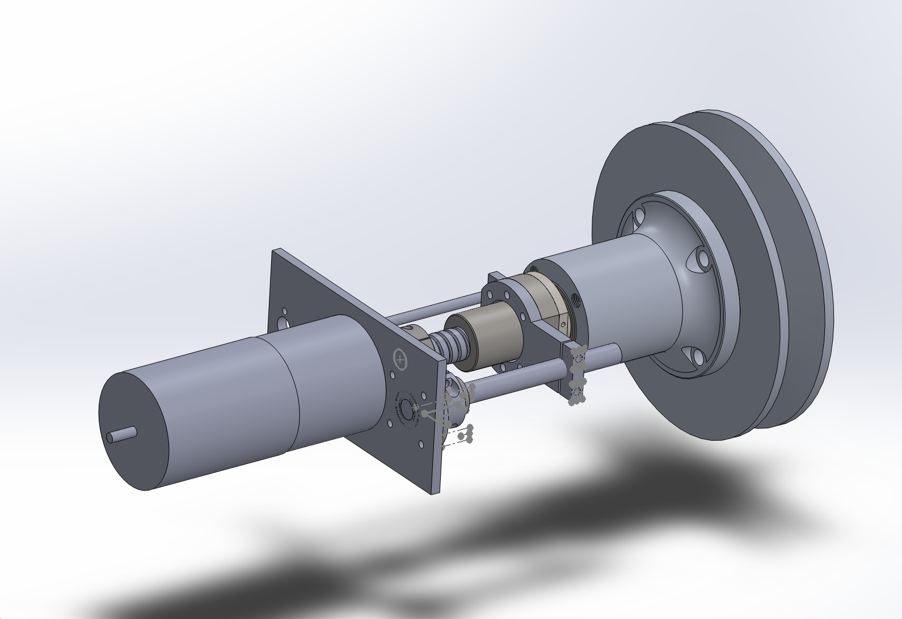

# INTRODUCTION

Okay, so Katie’s design doc covers almost everything you need to know about eCVT so you should surely read that. This design doc is going to be different, focused on the mechanical design exclusively, and it is not going to be as pretty - sorry!  
  
The first thing you need to do when working on this project is to understand how CVTs work. To do that, I would recommend reading Olav Aaen’s Clutch Tuning Handbook which I have uploaded to this drive folder. It goes over everything that you need to know about how CVTs function, and also provides some essential equations for the design process.

This design document will provide you with all the information necessary to get parameters to design your eCVT. I am not saying that this stuff is correct, but it is what we did this year.

Also, as a caveat, I did not design some of the components in this assembly. Much of that work was done by Konrad. But, I believe that he modeled the CVT design (Sheaves, Flange) off of standard CVTs that we have used in the past. Another caveat, a lot of these calculations are overestimations for safety reasons.

# DESIGN OVERVIEW

The eCVT system is composed of the following components roughly from right to left in the figure below:

1. Static sheave
2. Moving sheave
3. Flange
4. Bearing
5. Flange adapter
6. [Ball nut](https://www.zyltech.com/zyltech-16mm-1605-antibacklash-ball-screw-w-ballnut-pre-cut-lengths-200mm-1300mm/)
7. [Ball screw](https://www.zyltech.com/zyltech-16mm-1605-antibacklash-ball-screw-w-ballnut-pre-cut-lengths-200mm-1300mm/)
8. [Coupler](https://www.mcmaster.com/60715K13/)
9. Motor
10. Mounting shit (the stuff above and below the ball screw)

I linked to the components that we bought. Everything else was manufactured using the materials as specified in the BOM that is uploaded to the drive folder.

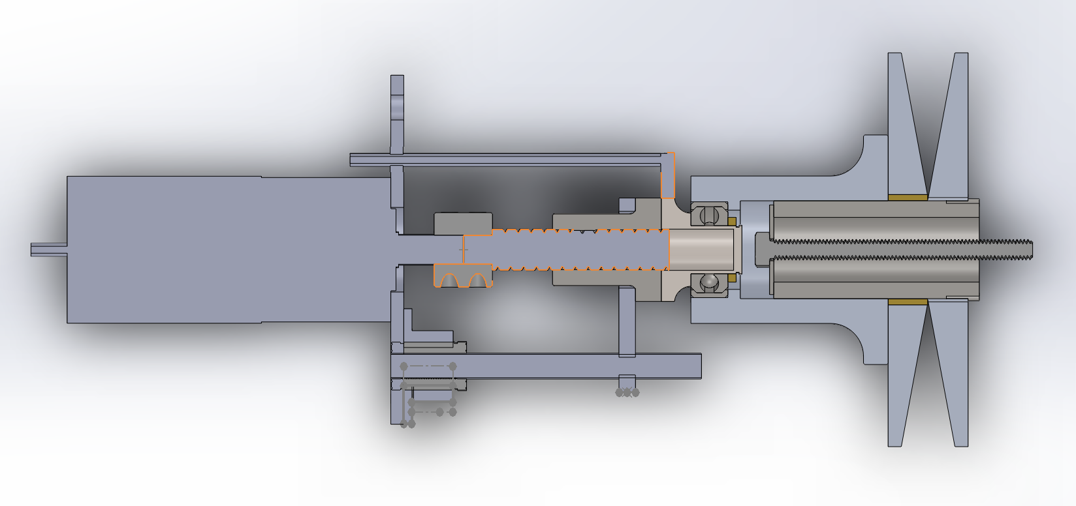

# DESIGN REQUIREMENTS

1. Sufficient force to move sheave and belt
2. Sufficient torque to create this sufficient force (through ball screw rotational to linear force)
3. The design does not fall apart

To make sure these design requirements were met, I did some math for all these conditions and then moved on to design in Solidworks

# SPECCING THE MOTOR: Side force

The first calculation you need to do is to figure out the side force that is required. Read page 17 of the clutch tuning handbook to get a better explanation of what this force is. Essentially, since we are only electronically actuating the primary, the secondary still has the good old spring and cam situation. The secondary’s sheaves only move based on the forces that are put on the belt from the primary. So, in order to know what kind of force we need from the primary, we need to analyze the resistive force on the secondary to give us the specification.

The side force is given by the equation below:

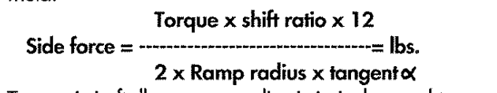

Since we know that the torque is the torque input from the engine and the rest of the parameters are based on the CVT secondary characteristics, we can find the side force required. See my calculation doc for more information on the assumptions that I made about the secondary (there were a lot).

Now that we have the side force requirement, we can continue to work backwards to spec the motor.

# SPECCING THE MOTOR: Ball screw time

Since the rotational action of the motor is turned into linear motion (and force) with the use of a ball (or lead) screw and nut – we can use the side force which we just calculated and some nifty ball screw equations to calculate the motor torque required to generate the desired side force!

The equation for the Torque to Thrust force conversion for a ball screw is below.

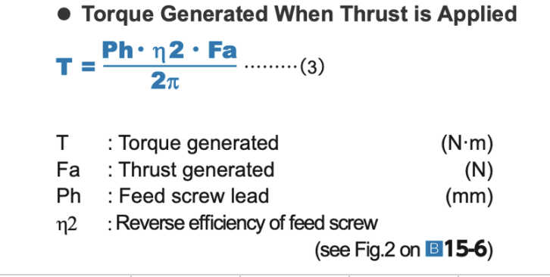

For our purposes, Ph is the maximum travel distance required, Fa is the side force, n2 = 0.7 for bad efficiency assumption, and that gives you the motor torque!!

We got roughly 3.8Nm for our estimation – which is a lot of torque :(. Motor speccing is a pain in the ass. See the motor selection a litter farther down for more info.

# BOLTED CONNECTIONS: Keep the eCVT together

The last calculations that you will need to do are those of the bolts. I am talking about the bolted connection seen below between the flange and the moving sheave.

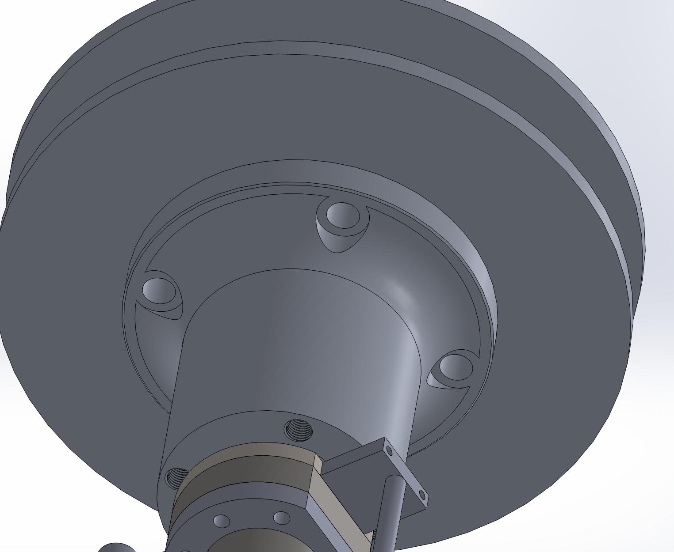

I had to read this section in the 315 textbook to understand what is going on, but the short of it is that you want to squeeze these two pieces of metal together enough that the friction between the surfaces is what keeps them together - not the bolts themselves.

To ensure this, there are three calculations you need to do. The flow is that the normal force in equation 2 is equal to the bolt preload Pi, and that the frictional force carries through between equations 2 and 3.

Bolt preload: **Pi = (3/4) * (Sp* (1/2)) * AT**

Force of friction: **Ffriction = μ * FN**

Reaction exerted by friction: **T = Ffriction * L**

The specification that you need to fulfill here is that **THE REACTION TORQUE IS GREATER THAN THE TORQUE OUTPUT OF THE ENGINE.**

You can also do some FEA on this bolted connection. I did not save the results of my simulation, sorry.

# MOTOR SELECTION

[This](https://www.phidgets.com/?prodid=1276) is the motor that we ended up going with (I think). The motor worked in the end, however, it was huge and required a lot of voltage to run. I have some experience from this and other projects with finding motors, so here are some helpful hints about (electric) motors!  
  
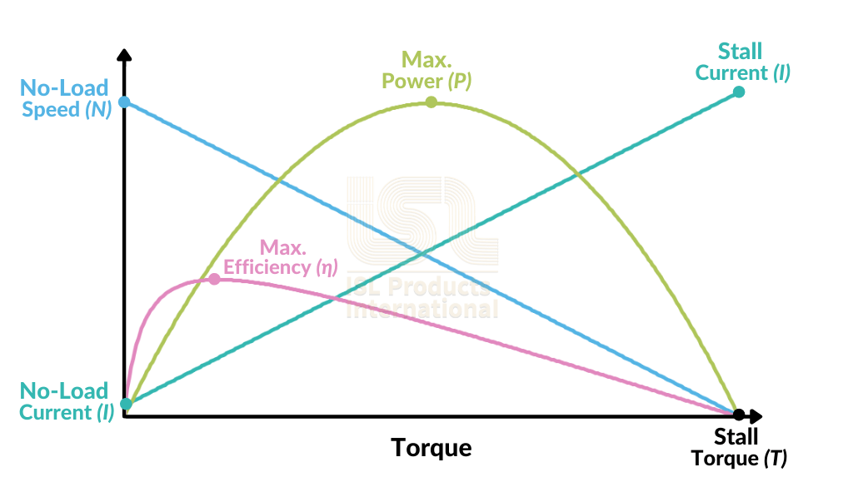

Example speed torque curve for some random motor

So as you can see above, here are some key features of DC motors:

1. Current is proportional to torque output
2. Torque output is inversely proportional to speed output
3. Stall torque = Peak Torque = the maximum torque the motor can output
4. No-load speed = the fastest speed the motor can spin (without any load obviously)
5. Gearboxes/transmissions can heavily modify the speed torque curve
6. P = current*voltage

Also, there are generally 2 kinds of electric motors you might use. 1 is *brushed* DC motors - they have brushes that automate the activation of phases of the motor which make them EASY TO CONTROL (comparatively). The other option is *brushless* DC motors which are better than brushed DC motors in almost every way except for the fact that they are much more difficult to control. I would recommend sticking with a brushed motor for this application.

Okay, so now knowing those things, you can go about selecting your motor. The main constraint here is the torque output (3.8Nm in our case). Often, when you are dealing with torque outputs this high you **need** a gearbox. Other constraints are weight, size, speed, and power consumption. All these are secondary to torque output, and since torque is such a strict requirement it will filter out most motor options for you to begin with.

# BATTERY STUFF

This was not my job at all this year, but I have since gotten a better understanding of how to spec a battery so I thought I would include this section.

Battery’s have two main characteristics, capacity (like how much energy they have) and C rating (rate at which a battery can be discharged relative to its maximum capacity). Yes, C rating is confusing, but here are some equations that will help clarify its importance.

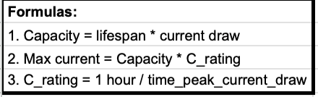

With these equations, you can approach the battery search one of two ways. First, you can either specify the lifespan that you require, and go from there. Or, you can explore different capacity and C-rating options available in market batteries. With these values, you can look at the options of lifespans and max current outputs that you can get. I would recommend the second option.

# SHEAVES AND FLANGE

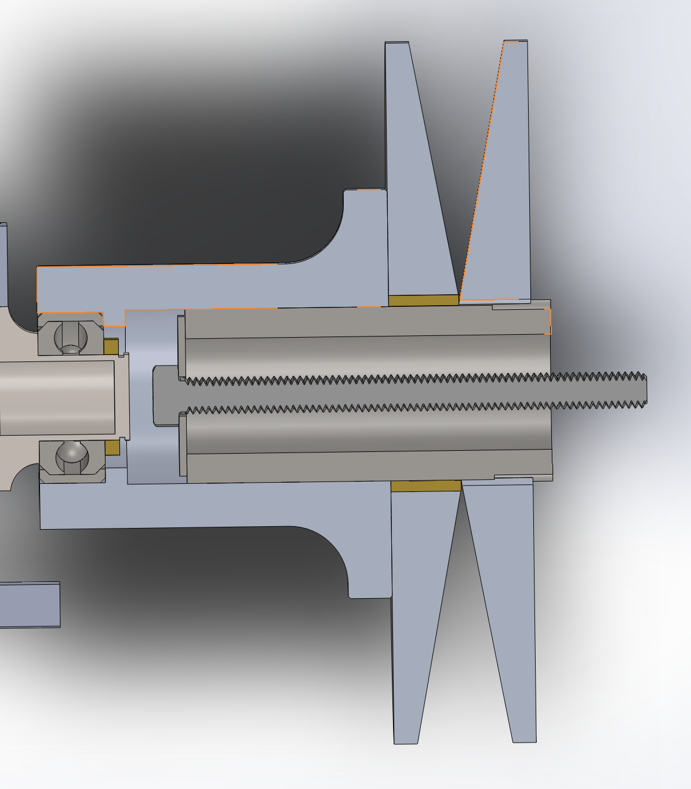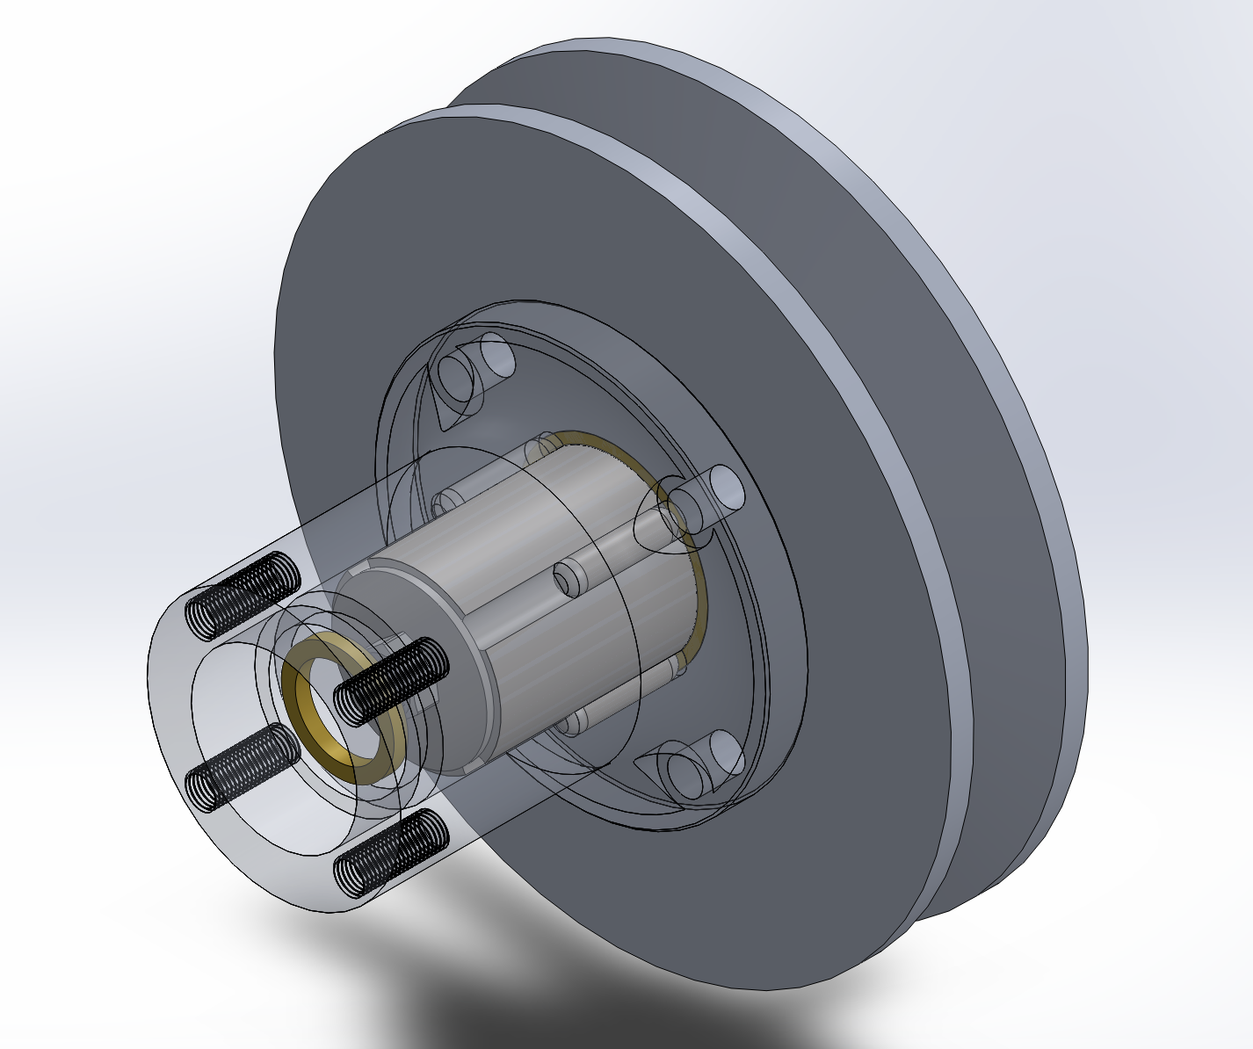

This and the following sections are a walkthrough of the mechanical design. Hopefully, by dissecting it this way you can have a good idea of the elements that go into this project.

The sheaves are the two angled plates that hold the belt between them. It is the movement of these sheaves that changes the ratio of the CVT. The sheaves are attached to the output of the motor shaft via the long screw which can be seen in the left image above (I am pretty sure lol).  
  
The sheaves and the flange which is bolted onto the sheaves are all spinning together with the motor output shaft. This motion is transferred through the ball spline which is surrounding the center screw and is interfaced to the flange by four dowel pins. These pins allow the moving sheave to traverse axially along the ball spline, but transfer the torque of the engine output to the sheaves.

# BEARING AND FLANGE ADAPTER

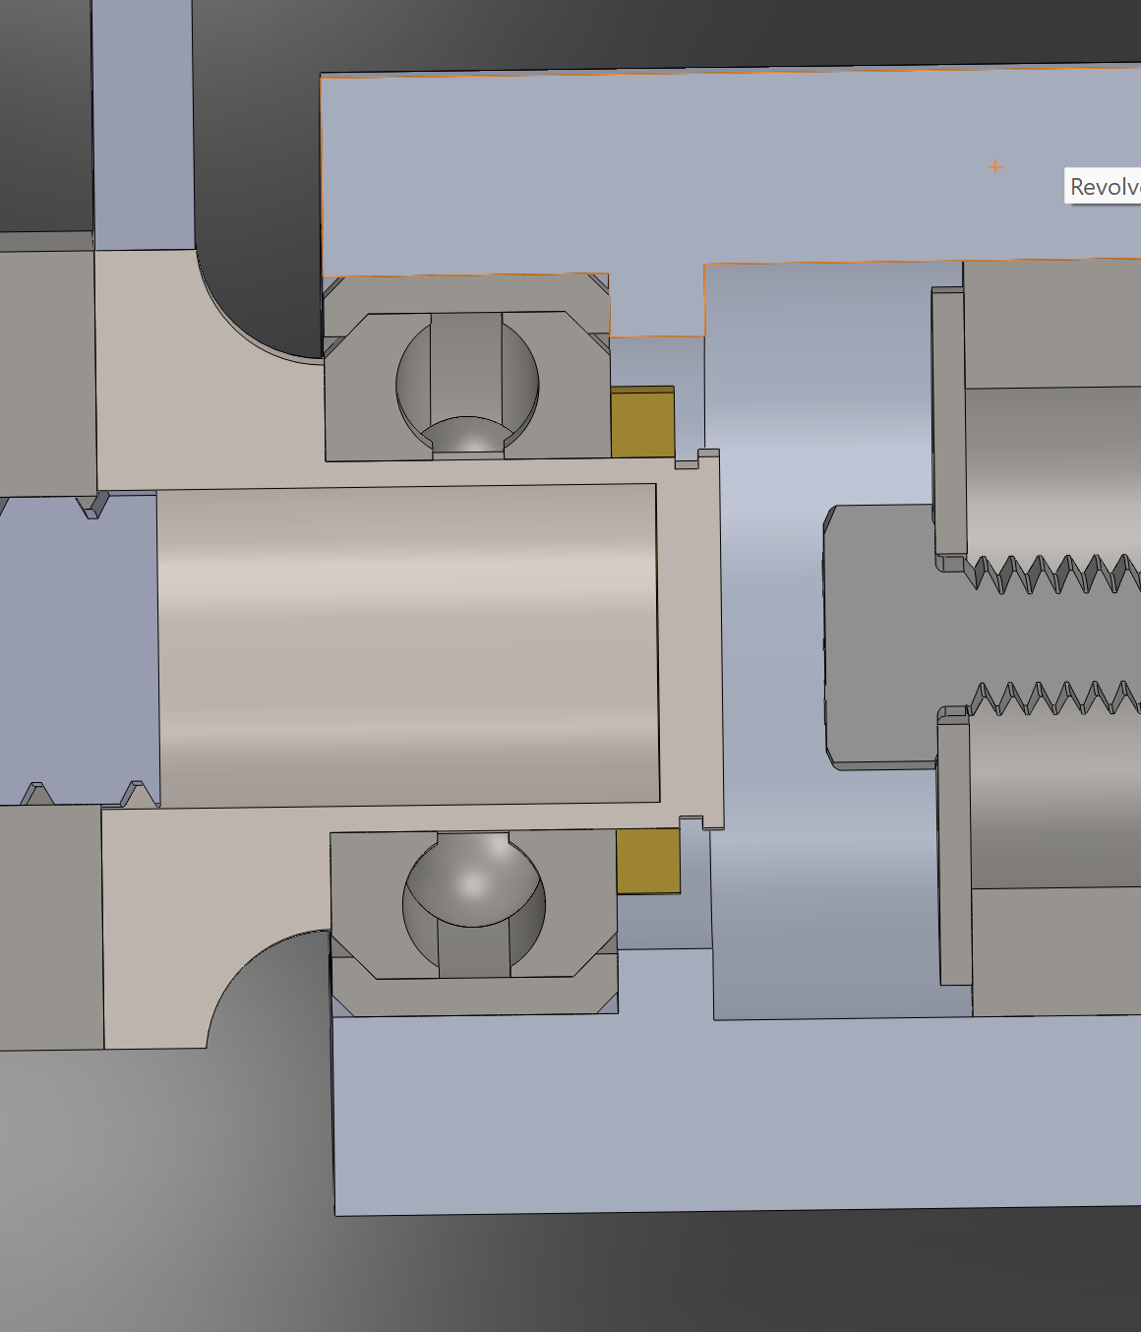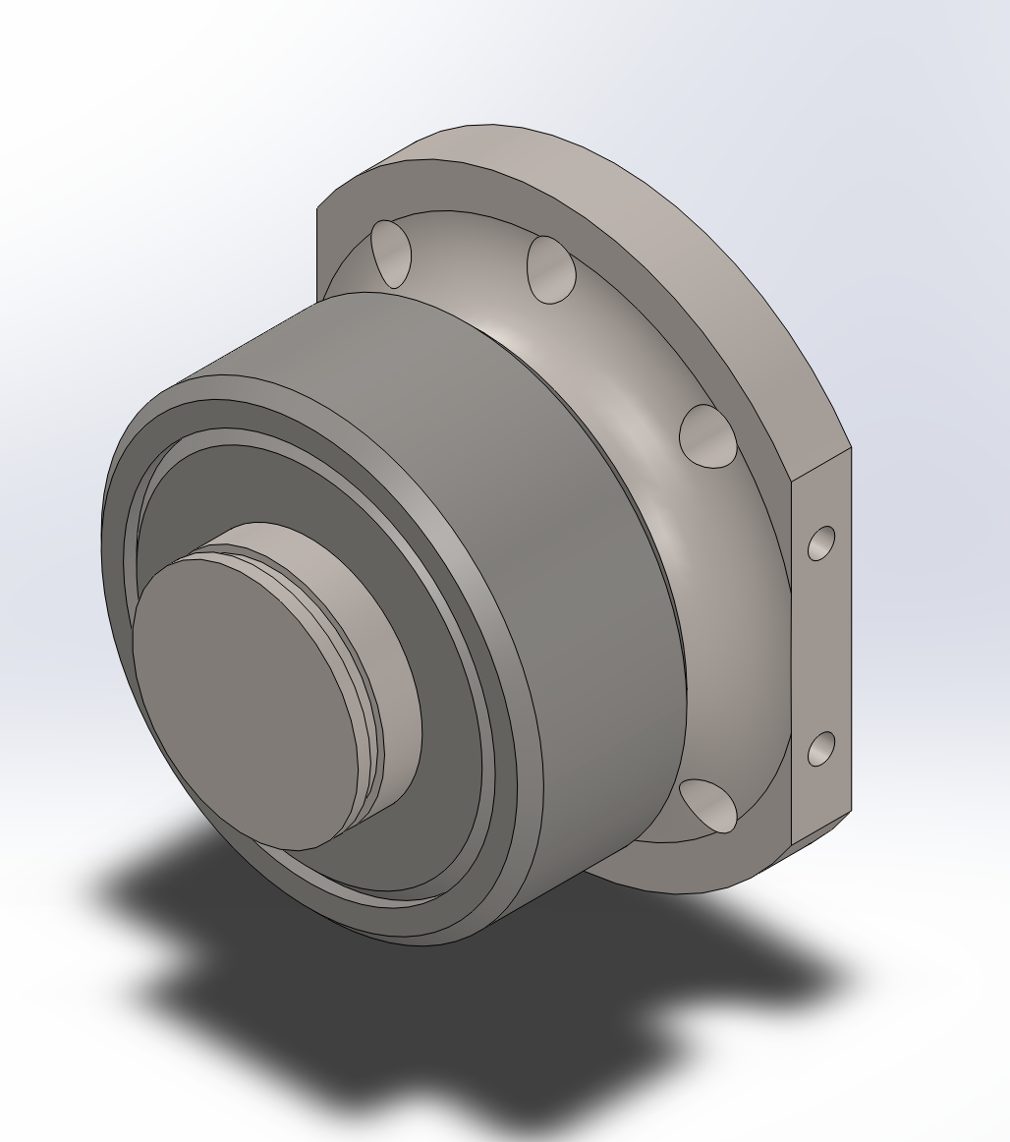

This next element represents a division between the rapidly spinning part of this assembly and the rest of it. The thrust bearing which is housed within the flange is the operator of this separation. The thrust bearing is interfaced with the flange adapter on its inner ring. The inner ring, and therefore the bearing, are held together and within the flange using a snap ring.

It is critical that there is clearance for the ball spline to travel within the flange and not collide with the flange adapter AND for there to be clearance for the ball screw within the flange adapter. There is not a pretty way of doing this, I used an excel sheet to add up all the lengths and take into consideration the travel length of the sheave as the ‘tolerancing’ or clearance needed.  
  
The flange adapter is ‘adapting’ the flange to the ball screw. So it is bolted or screwed into the ball screw…

# BALL SCREW

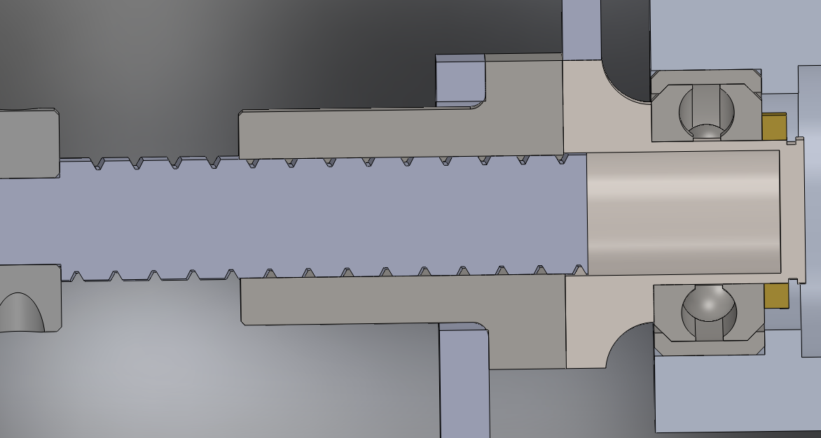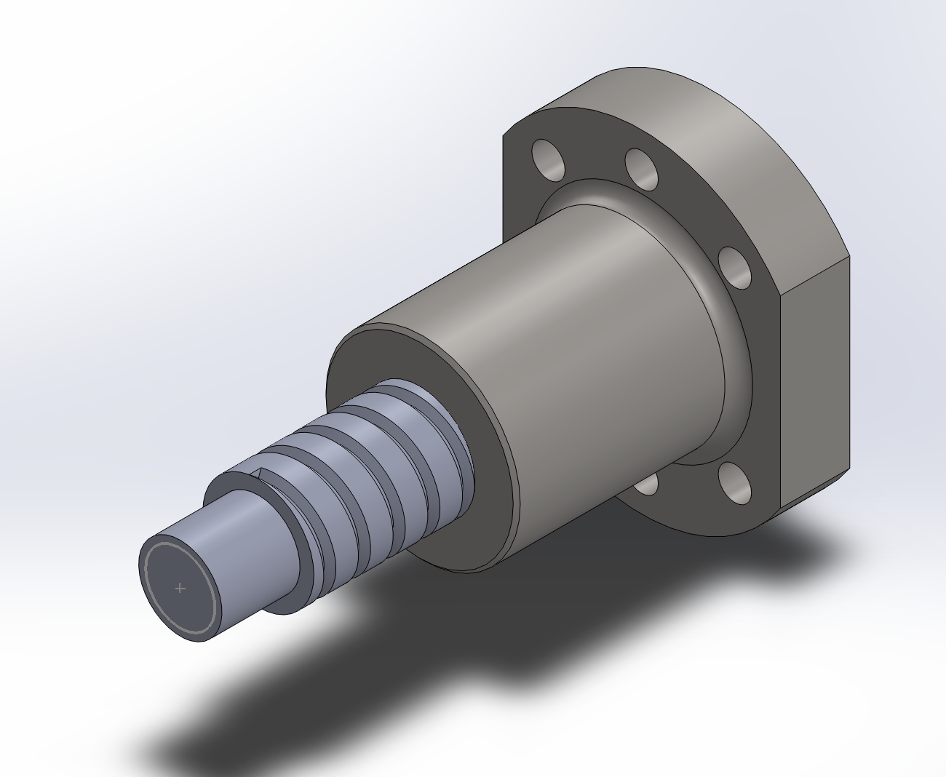

The ball screw is the mechanism which turns the motor rotational force into linear force. I would encourage a future designer to explore different methods with which to perform this actuation, this is by no means a perfect setup.

Ball screws are just screws, and so you can choose the pitch and diameter that you think will work best. We chose 1605 - 16mm diameter and 5 mm pitch - somewhat arbitrarily and went with it. We purchased the ball screw [online](https://www.zyltech.com/zyltech-16mm-1605-antibacklash-ball-screw-w-ballnut-pre-cut-lengths-200mm-1300mm/) and then I cut it down to size because they were all too long online.

# COUPLER

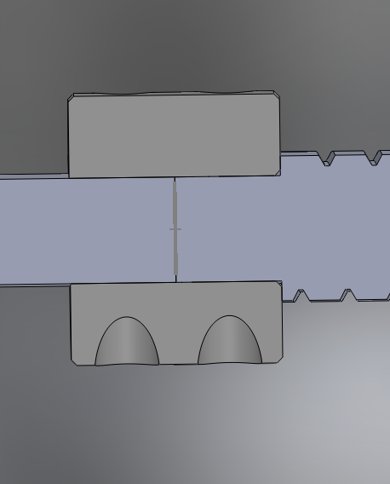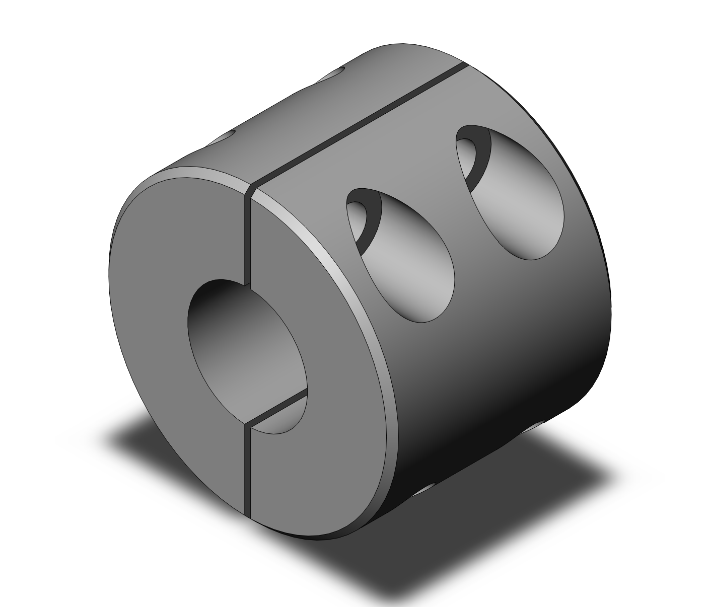

The coupler connects the ball screw to the motor shaft. This worked well in our case because the motor shaft had the same diameter as part of the ball screw. I chose a random compression coupling off McMaster and then had to manufacture that. It was HORRIBLE. There is a reason professionals make these.  
  
The main issue was that the holes are so small for a coupling this small. I think I broke (with them help of others) around 4-5 drill bits and multiple taps in the process, so I had to restart manufacturing almost 4 times. That was like the worst thing ever, don’t do that to yourself.  
 **If you still want to make a coupling this small, here is the secret. Make sure that you plunge both ends of the screw hole with an end mill before drilling. This is because if you do not, the drill bit will be exiting out of an angled surface (same with the tap) and so this is what likely caused all my issues.**

It is not shown, but only one half of the compression coupling has threading because that is how you design these.

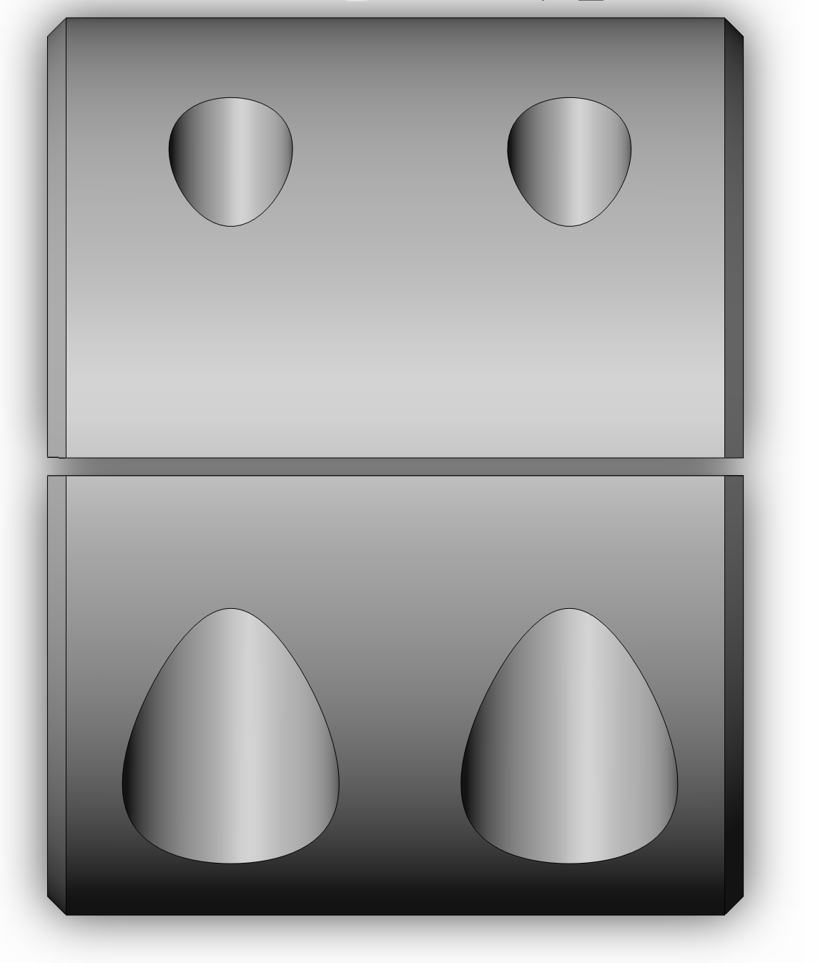

# MOUNTING

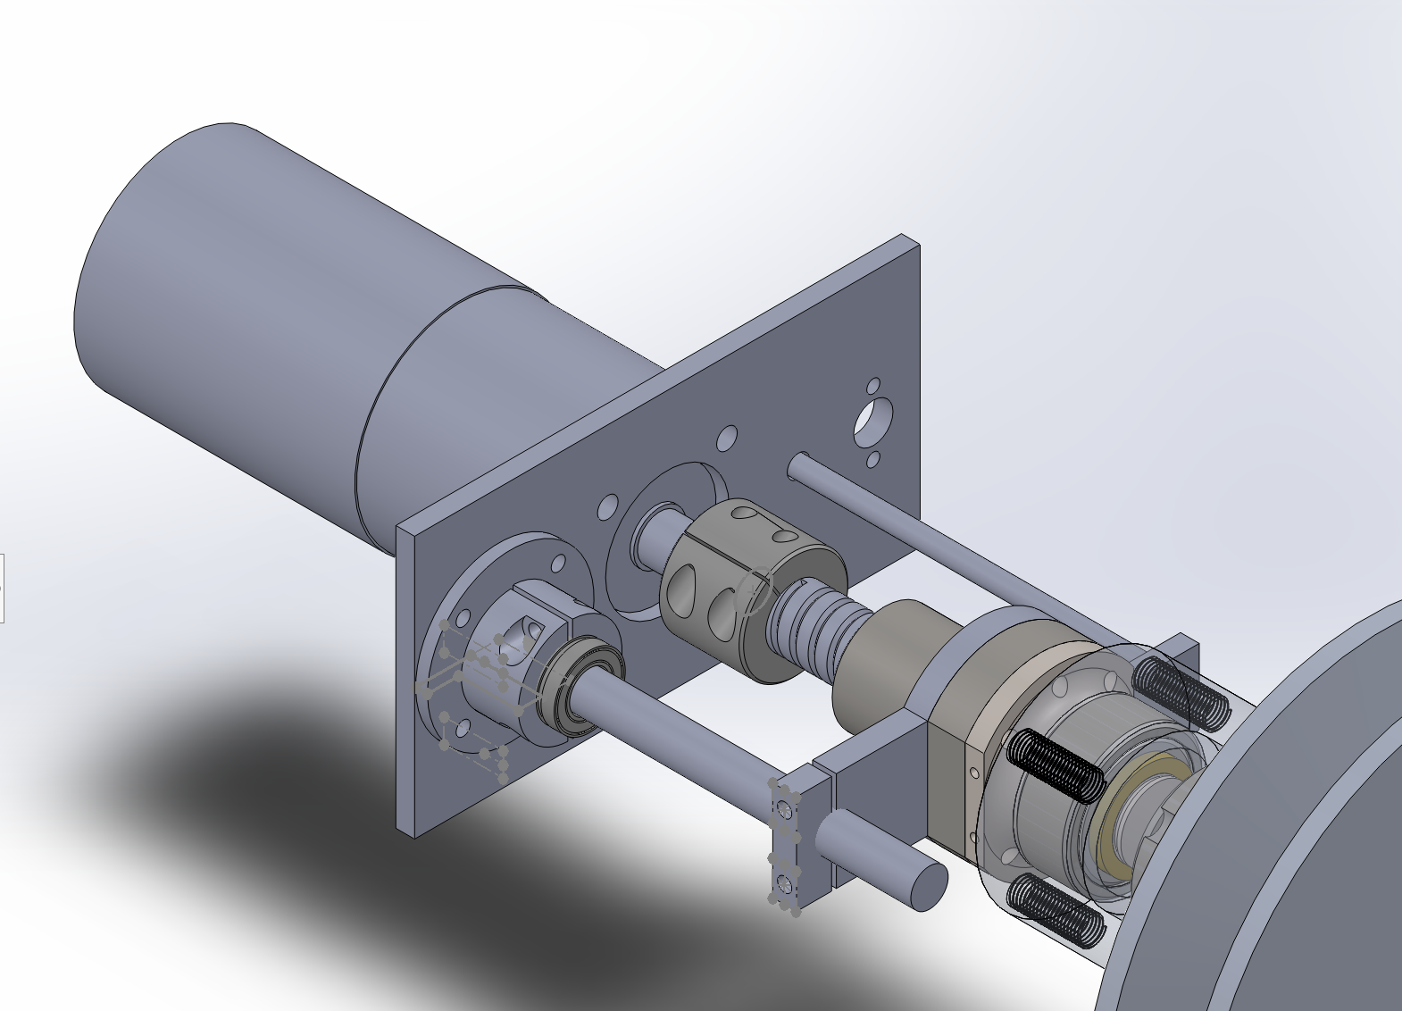

Mounting is important so that the ball screw performs as intended. If the ball nut is not mounted to a non-rotating surface, it will just spin and the ball screw will not move the sheave. So, you need to connect the motor to the ball screw. As you can see above, that is not easy to do elegantly. The two rods that are running parallel to the ball screw are 1 for mounting and 2 for the linear potentiometer.

Our idea was to have a rod that is inside of a linear bearing which is connected to the ball nut. It worked pretty well, but I would not call this ‘robust’. It is certainly the most mechanically weak element of our design.

While we are on mounting, you can see the mounting plate that is attached to the motor. This plate was mainly for the linear potentiometer and any other sensors we needed, as well as the mounting for the ball screw rod.

# CONCLUSIONS AND LESSONS FOR NEXT YEAR

That should be everything you really need to know. It is pretty straightforward, although there is a lot to digest. Before I wrap up, I would like to offer suggestions for next time!

1. Explore a new way to mount the motor.

This year we just coupled everything linearly so that the assembly extended outside of the roll cage/chassis. This was a huge liability, and one of the main reasons we did not use the eCVT at comp. If you can figure out how to mount the motor with a pulley or gears or another way of transmitting torque to the lead screw, you would be able to reduce the assembly size a lot.

1. Explore new ways to actuate the moving sheave.

There are many other schools who have done eCVT, and they have found some creative ways of performing this actuation. I think one school had a pneumatic actuator or something. Point is, maybe there is a better way to make that sheave move?? Check out other schools' projects for inspiration such as Cal Poly or Michigan. They also do a great job of documenting their work, so it is worthwhile to look around for it.

Alright, I think that is everything. Please reach out to me if you need anything clarified or would like to talk through the design process! Best of luck.

Michael Jenz